PICTURES FROM THE AGM AND 55th SASAS CONGRESS HELD FROM 8 TO 10 July 2025 IN POLOKWANE
SASAS AWARDS
Silver medal – 2024
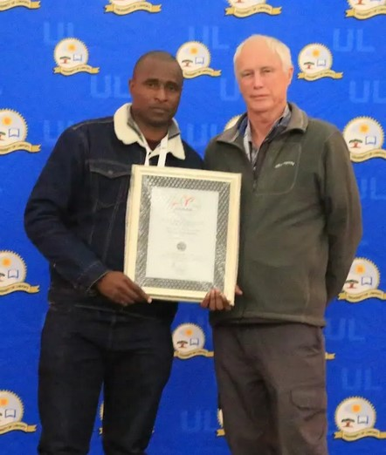
Prof Cletos Mapiye winning the Silver Medal
Bronze medal – 2024
Dr. Trevor Dugmore, presented the bronze medal to:
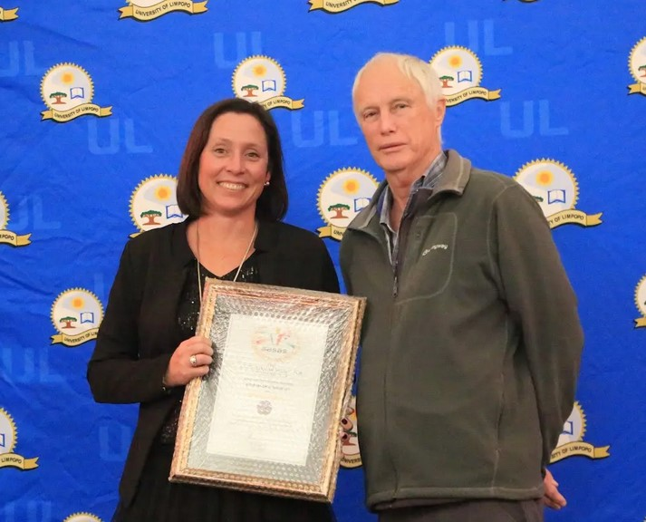 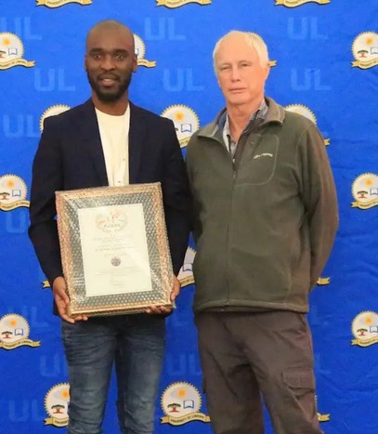
Dr Robyn Joubert Dr Simeon Muthana
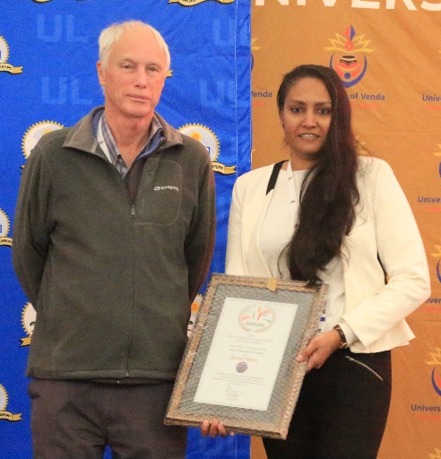
Dr Georgette Pyoos
DAVID UYS TROPHY
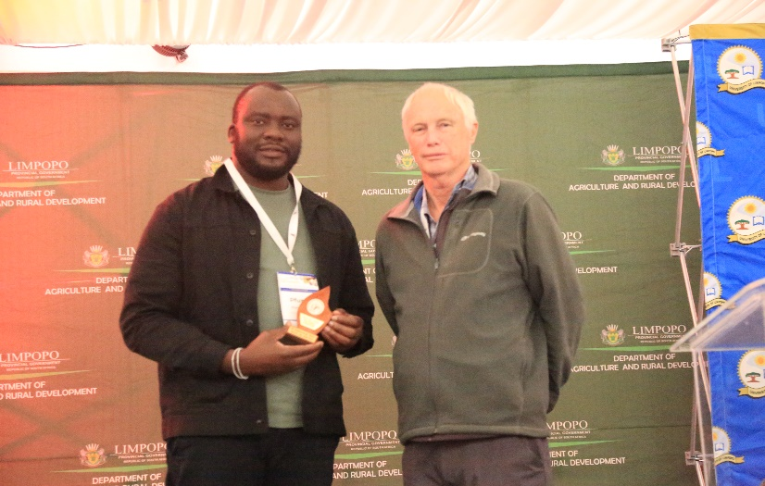
Dr P.T. Muvhali received the David Uys Trophy on behalf
of the authors, M. Brand et al.

PICTURES FROM THE CONGRESS
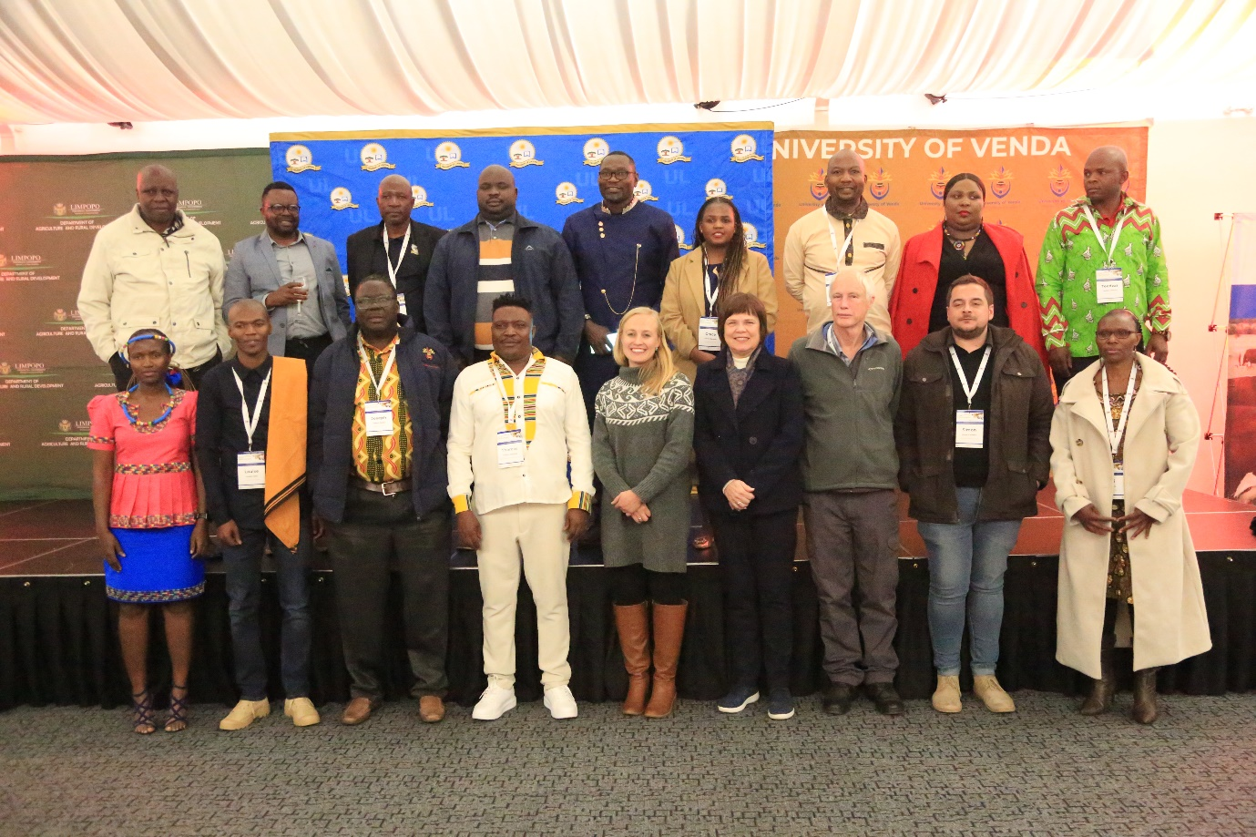
Members of Local Organising Committee and SASAS Council
Debate winners
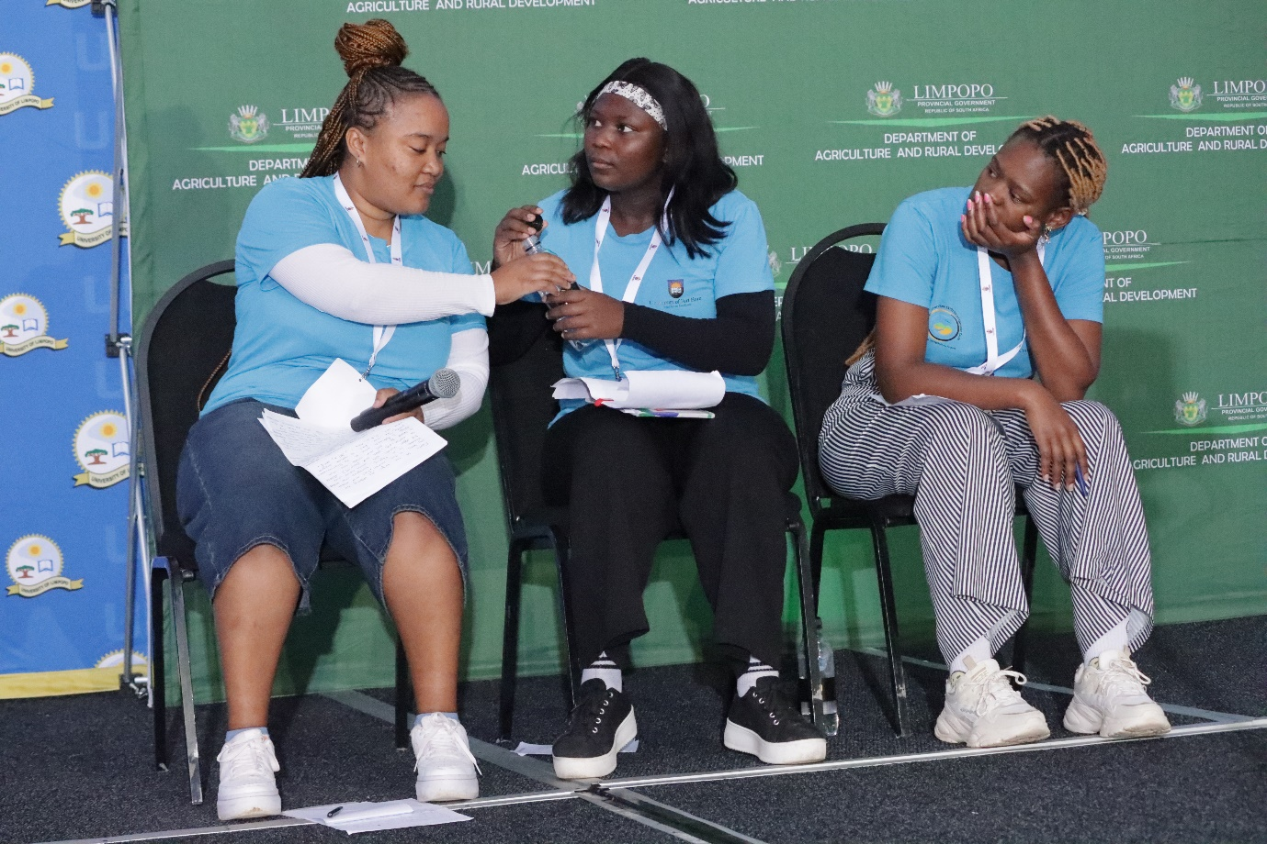
1. University of Fort Hare - Name of the team: Ruminant Rebels
Ms Azasakhe Skolpati, Ms Lindokuhle Tukula, & Ms Sinovuyo Luphuzi

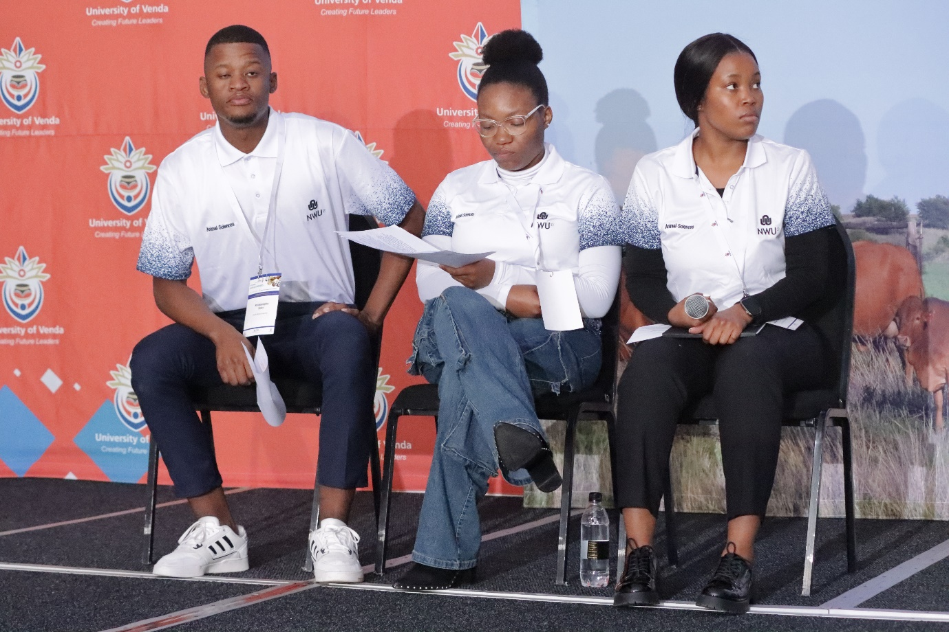
2. North-West University - Name of the team: Purple Army
Mr Nhlakanipho Soko, Ms Rudorwedu Shanduka, & Ms Ramokone Millicent Mokonyama

QUIZ WINNERS
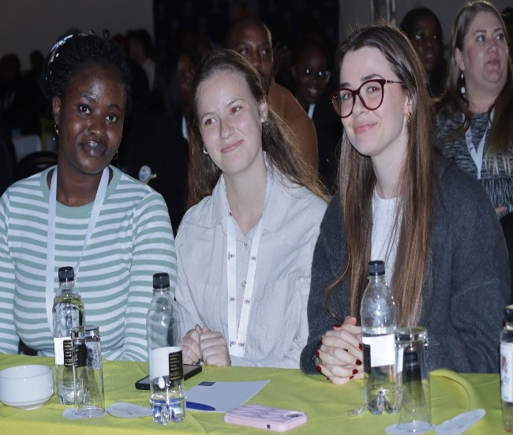
- Stellenbosch University - Name of the team: The Ruminerds
Ms Tshilidzitshawe Rapudi, Ms Emma Botha, & Ms Lize-Mari Snyman

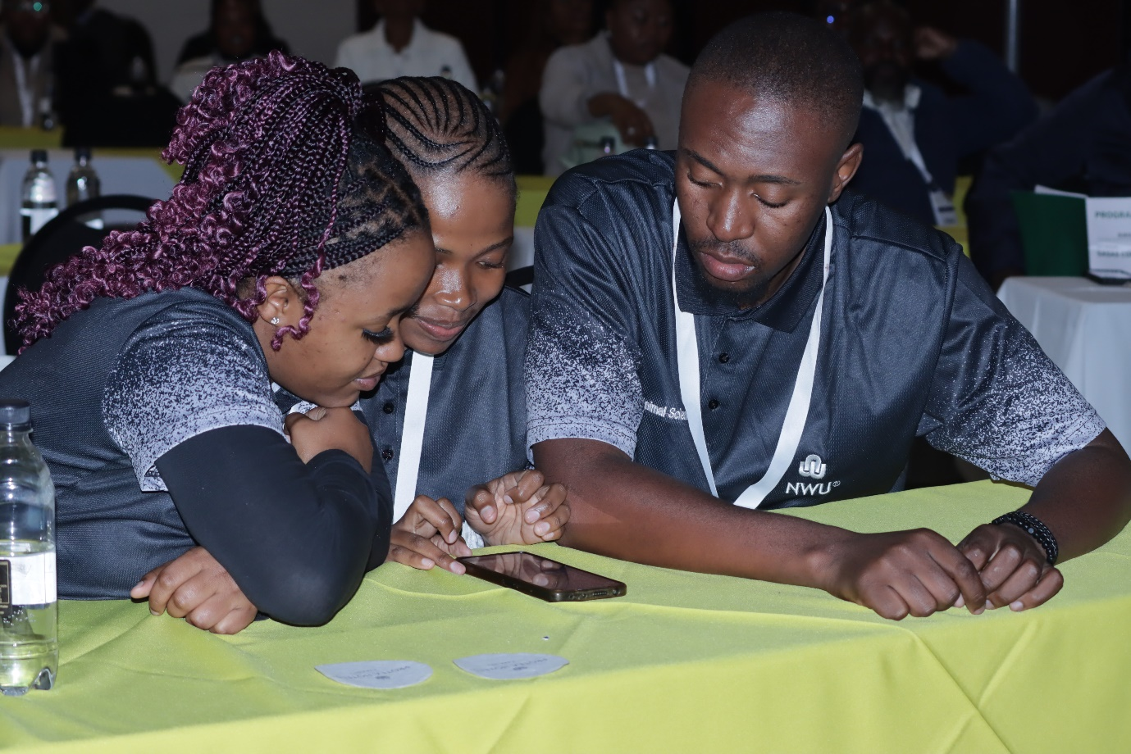
2. North-West University - Name of the team: Purple Army
Ms Pharoe Palesa, Ms Kgomotso Hlongwane & Mr Innocent Twala
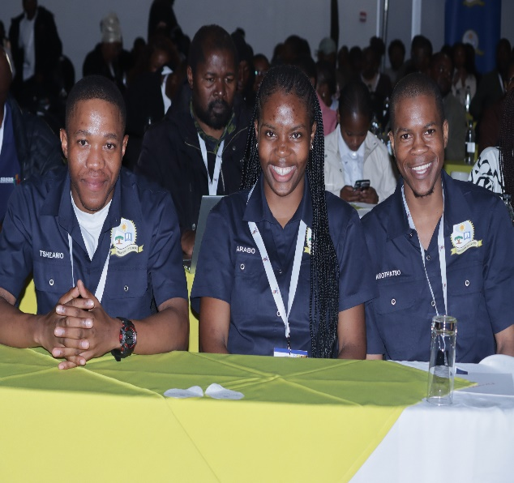
3. University of Limpopo - Name of the team: Sovenga Blues
Mr Bapela Maunatlala Tsheamo, Ms Karabo Kgodu Maremane & Mr Kgothatso Mailula

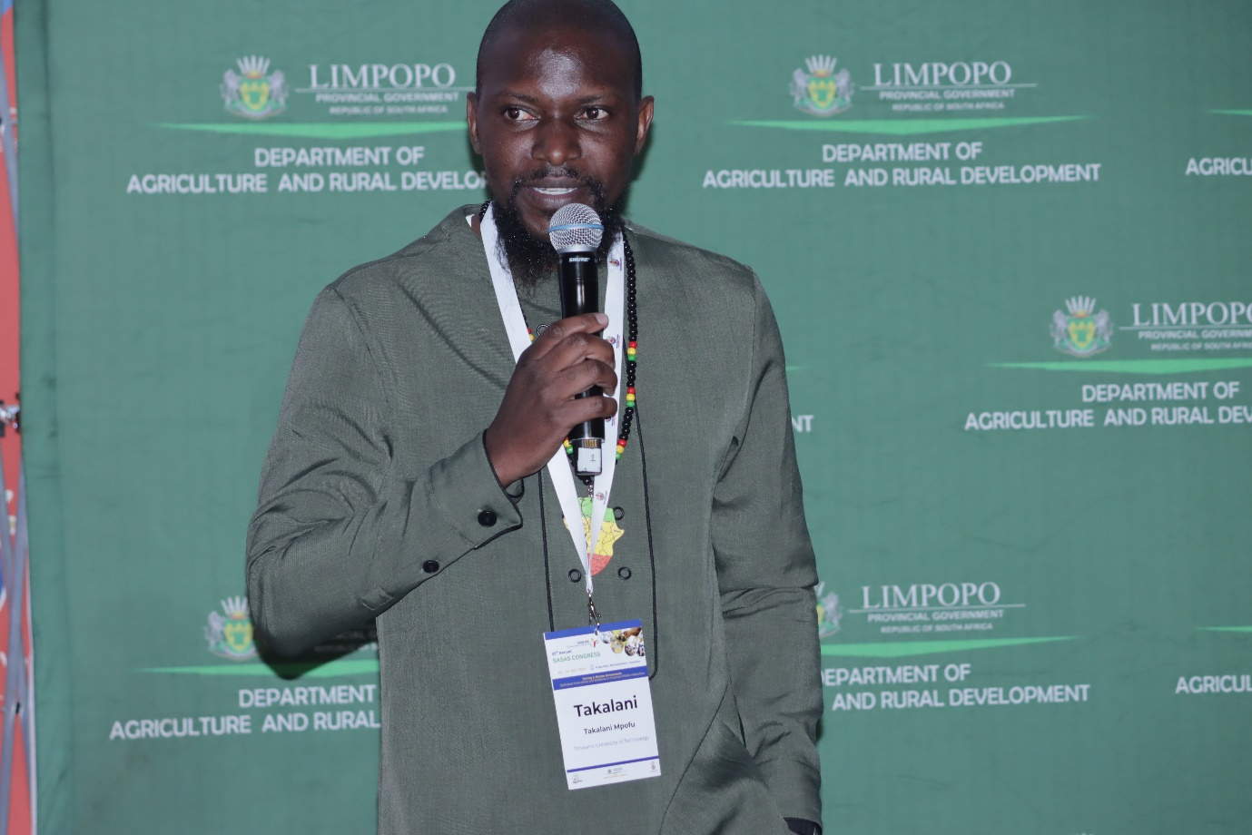
Prof TJ Mpofu Quiz and Debate Master
Student Posters Award Winners
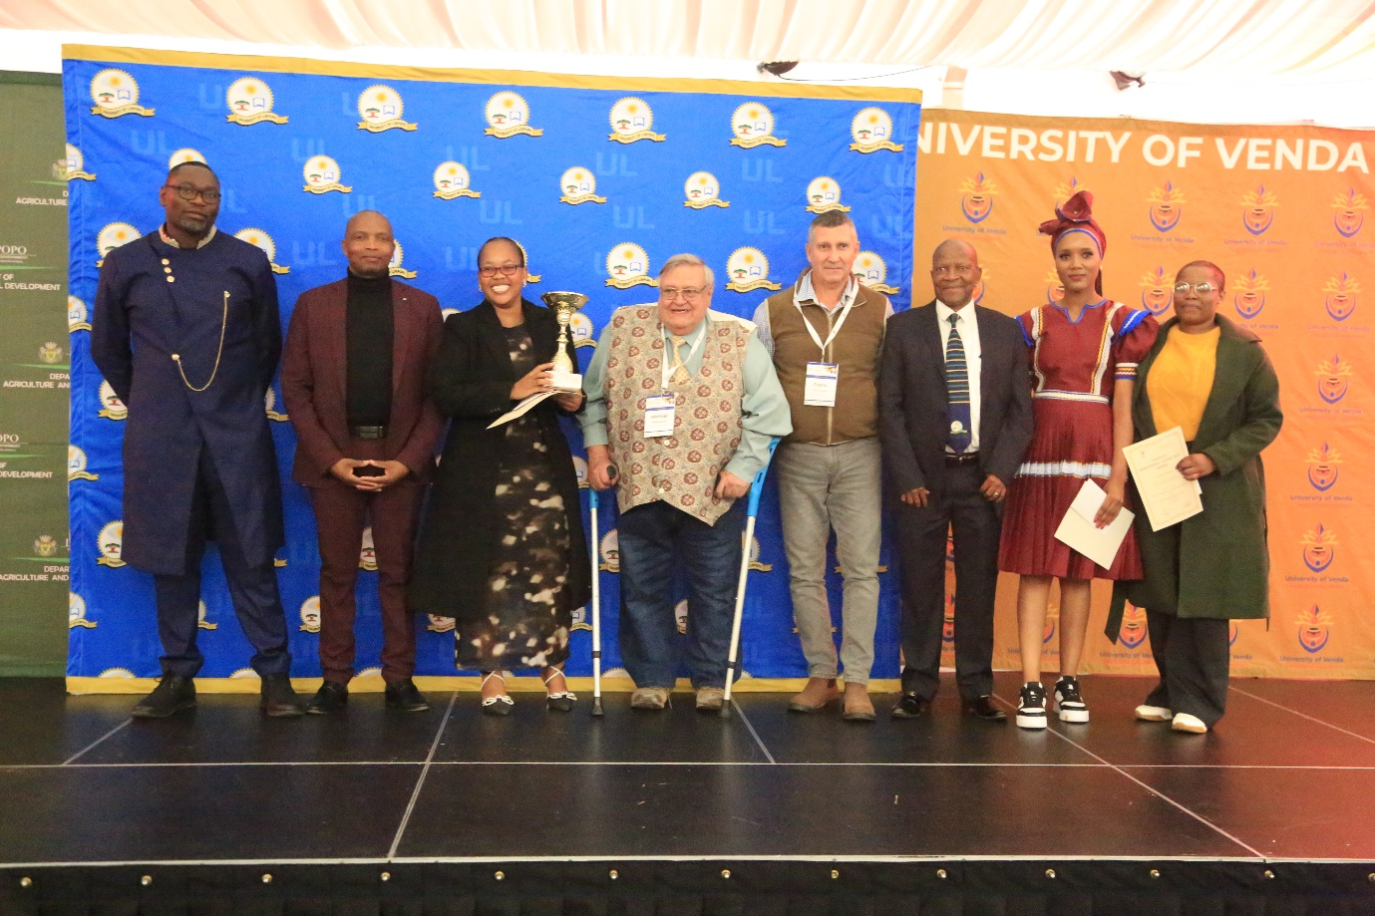
Livestock Improvement Scheme Trust (LIST): Animal Breeding and Genetics Poster Winners
Position 1: Mashamaite, Puleng
Position 2: Moholola, Nthabiseng
Position 3: Ledwaba, Mahlatsana Ramaesela

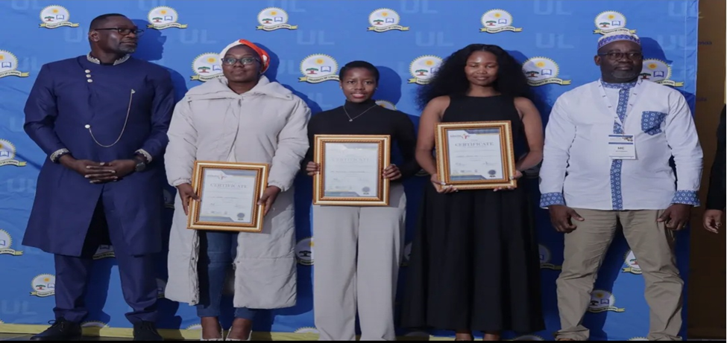
Animal Nutrition Poster Award winners
Position 1: Sindaku, Lihle
Position 2: Ditabo, Atharlia Bontle
Position 3: Thobejane, Hypatia

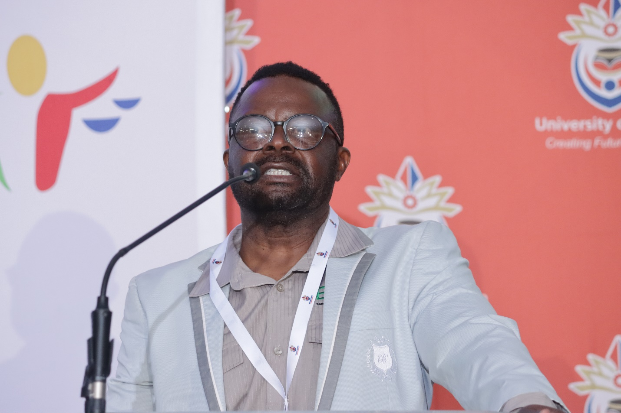
Keynote address: Prospects for achieving sustainable dairy production in diverse and increasingly harsh environments:
Prof CB Banga - Botswana University of Agriculture and Natural Resources.

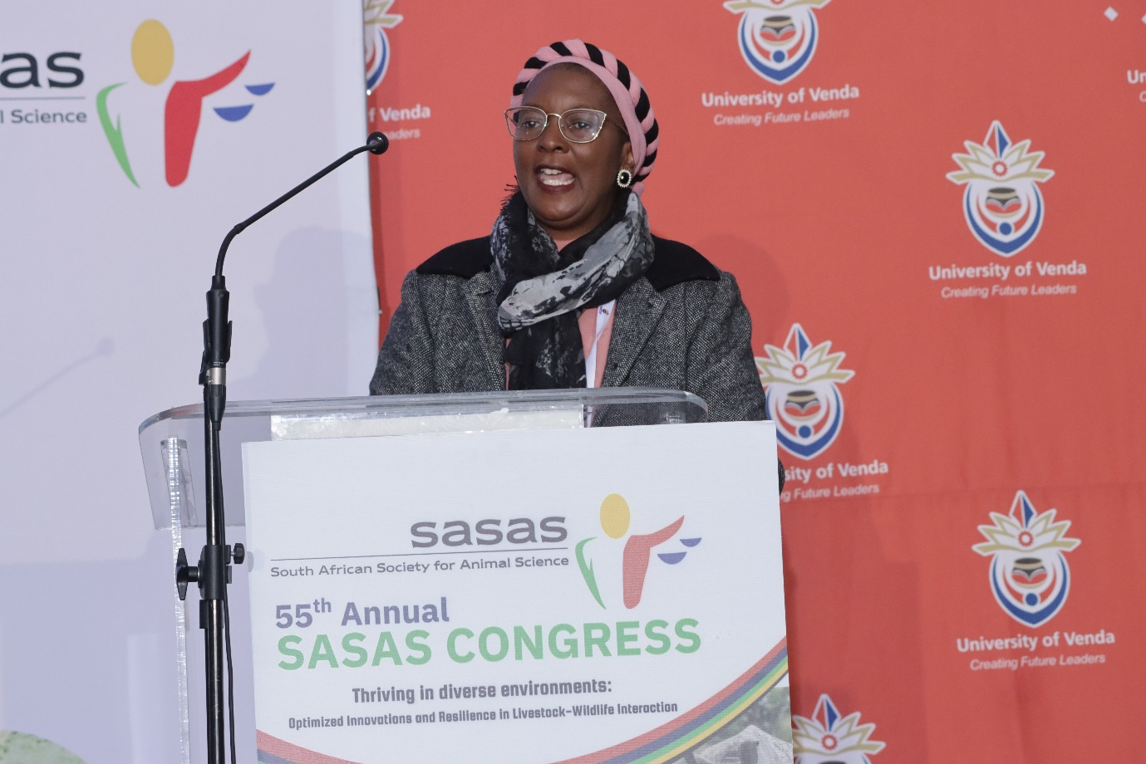
Keynote address: Application of molecular genetics and novel strategies to improve animal performance and resilience:
Prof. TO Amushendje - (UNAM-Namibia)
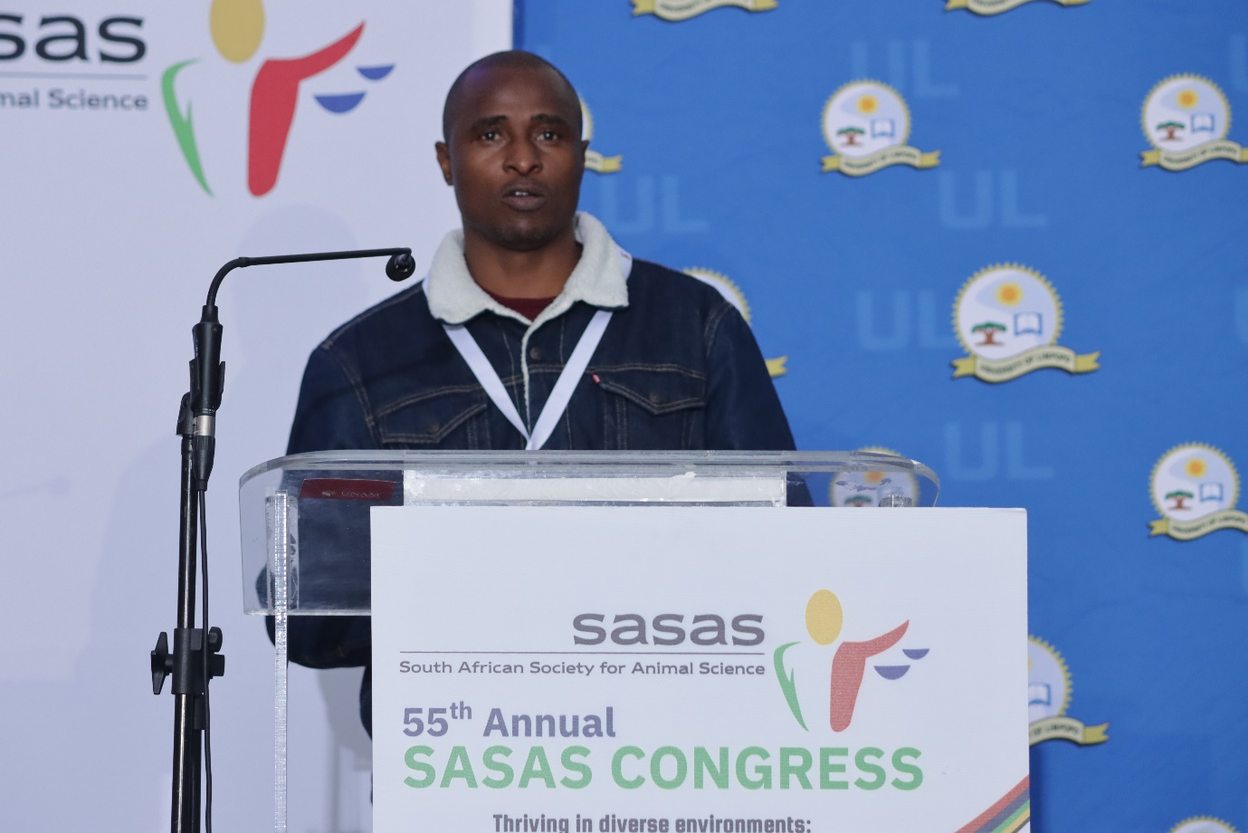
Keynote address: Evolution of consumer preferences and perceptions of red meat: Insights into the role of climate-smart phytogenic feedstuffs:
Prof C Mapiye (Stellenbosch University- RSA)

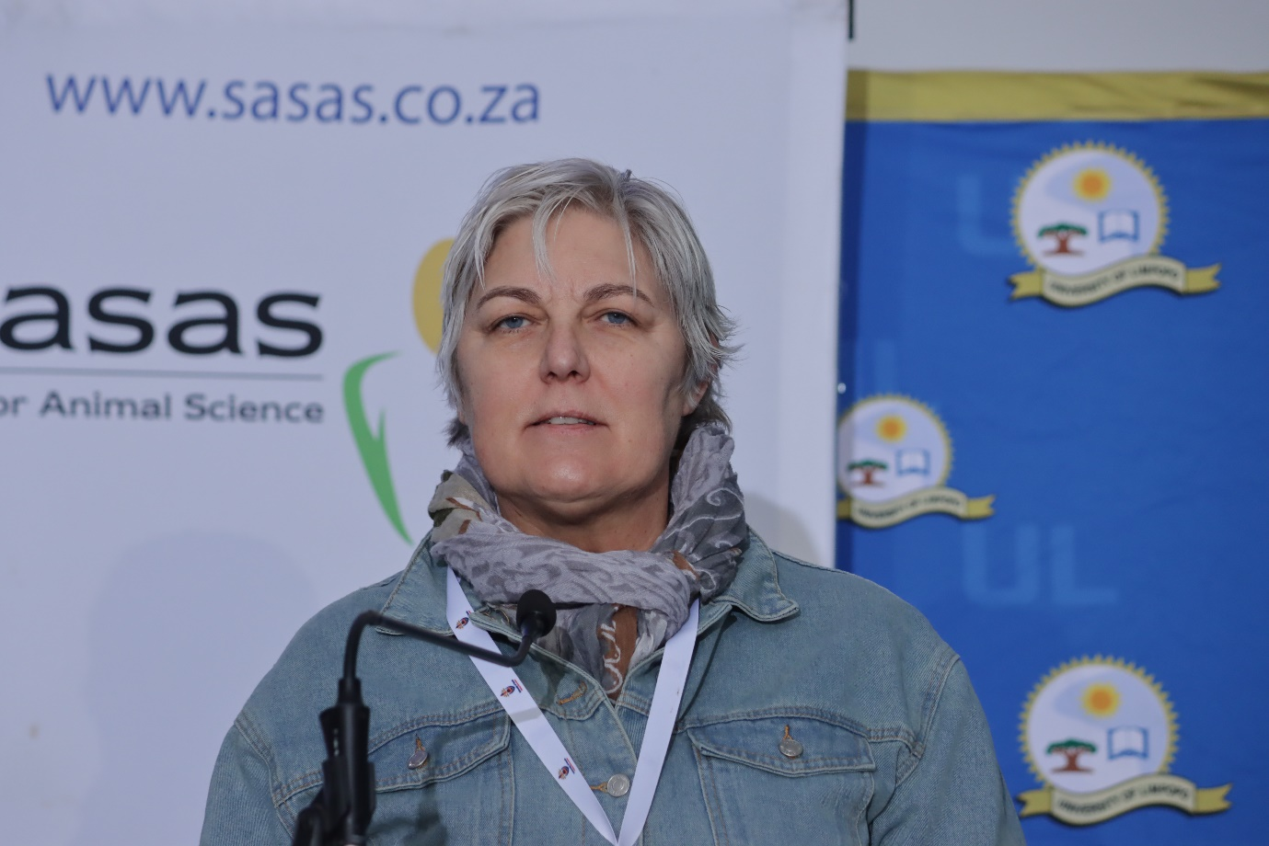
Keynote address: Novel approaches to animal physiology-climate smart agriculture and sustainable intensification
Dr H Lambrechts (University of Stellenbosch-RSA)

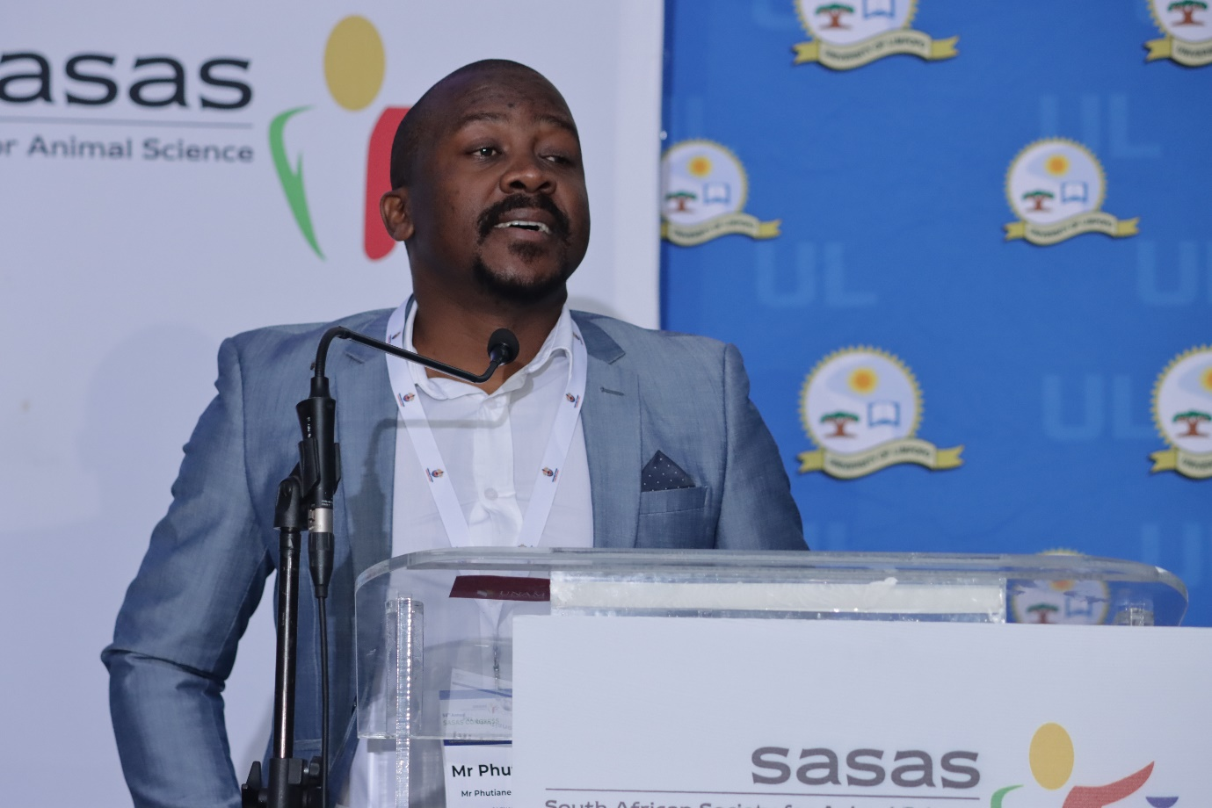
Keynote address: Formal Recognition and Regulatory Compliance for Animal Scientists: Navigating SACNASP Requirements under the NSP Act:
Mr Phutiane Letsoalo (SACNASP)

